Electric Longboard Mark II

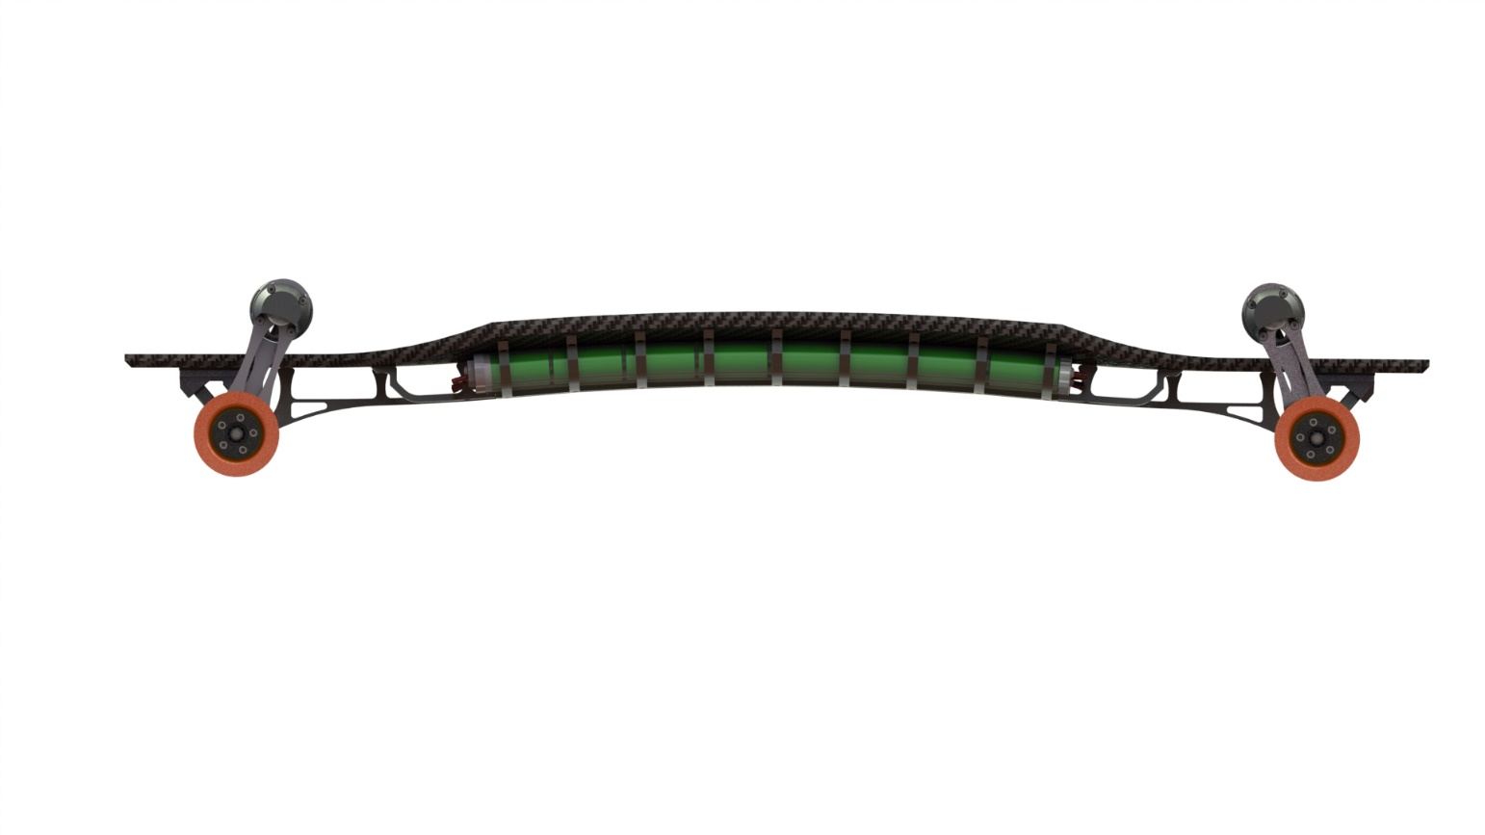

|  |
| --- |
|  |
|  |

Open-Source Project by Daniil Andreev

Oct. 16, 2017

Contributors

|  |  |  |
| --- | --- | --- |
|  |  |  |
|  | Anton Zaytzev | * Reed College |
|  | Sam Ragsdale | * Washington University in St. Louis |

Motivation

The reasoning behind this project is simply my interest in building stuff, as well as something akin to being able to ride my own resume to a job interview. But the initiating thought was; to build something so outrageous it would stink of Snowcrash.

The project started during the end of my first year as an undergrad at Knox College. I had looked at the commercially available Boosted Board and figured I could make something way more powerful.

Having no training in electronics, I spent the rest of the year attempting smaller projects that would help me build the skill required to attempt an electric vehicle. 3 years later and 12k in, I am just starting to see the finish line.

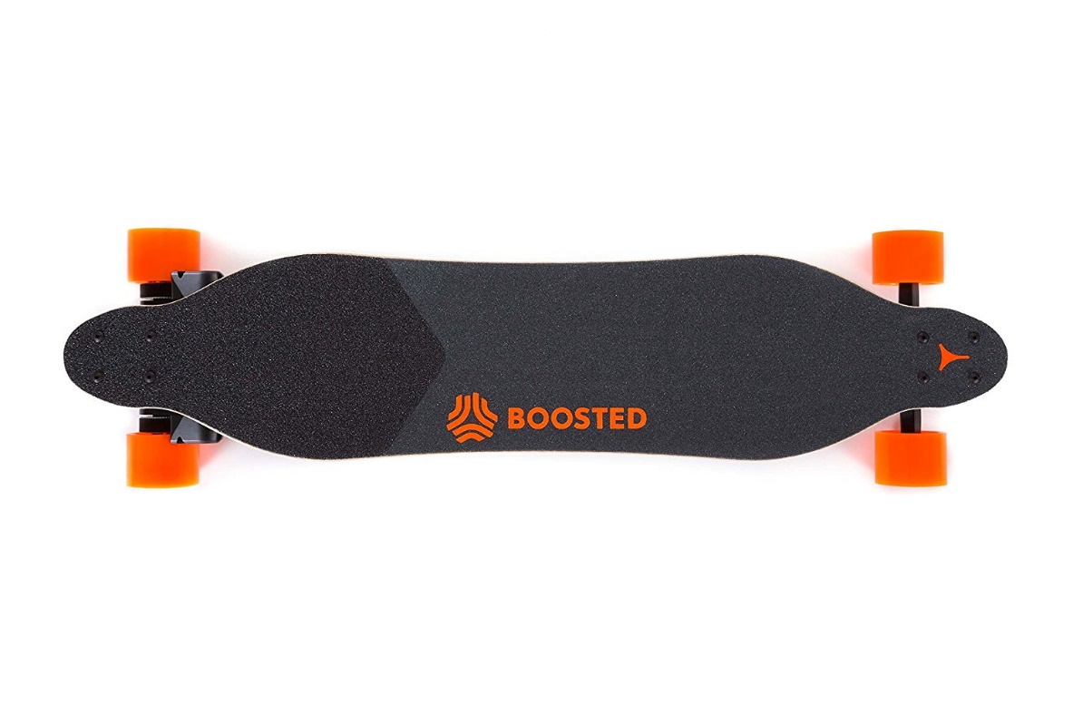

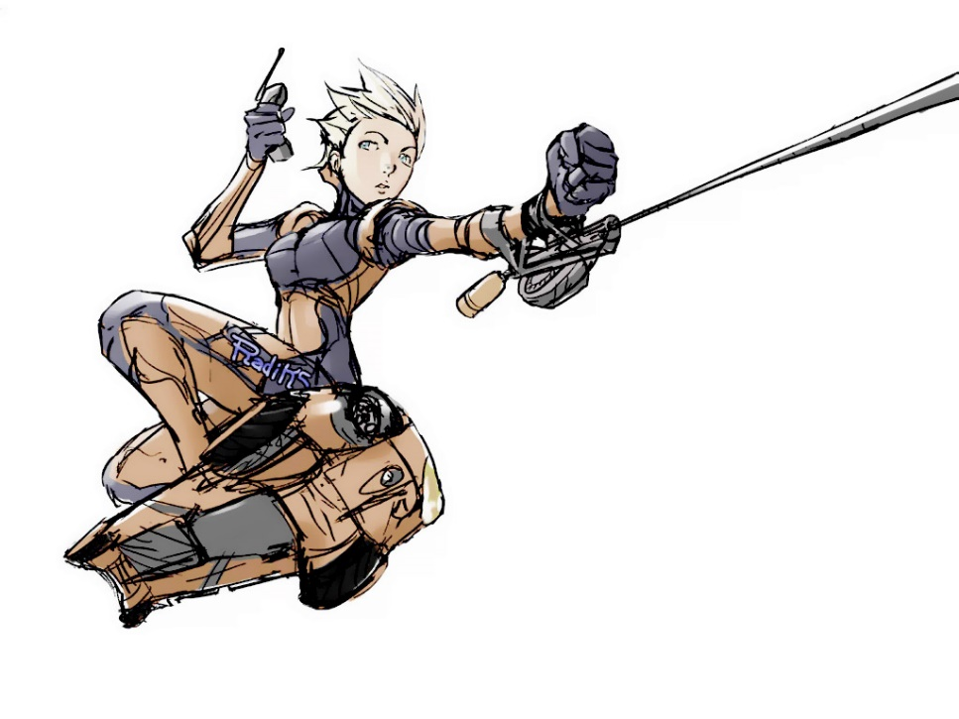

Mechanical Design and Model

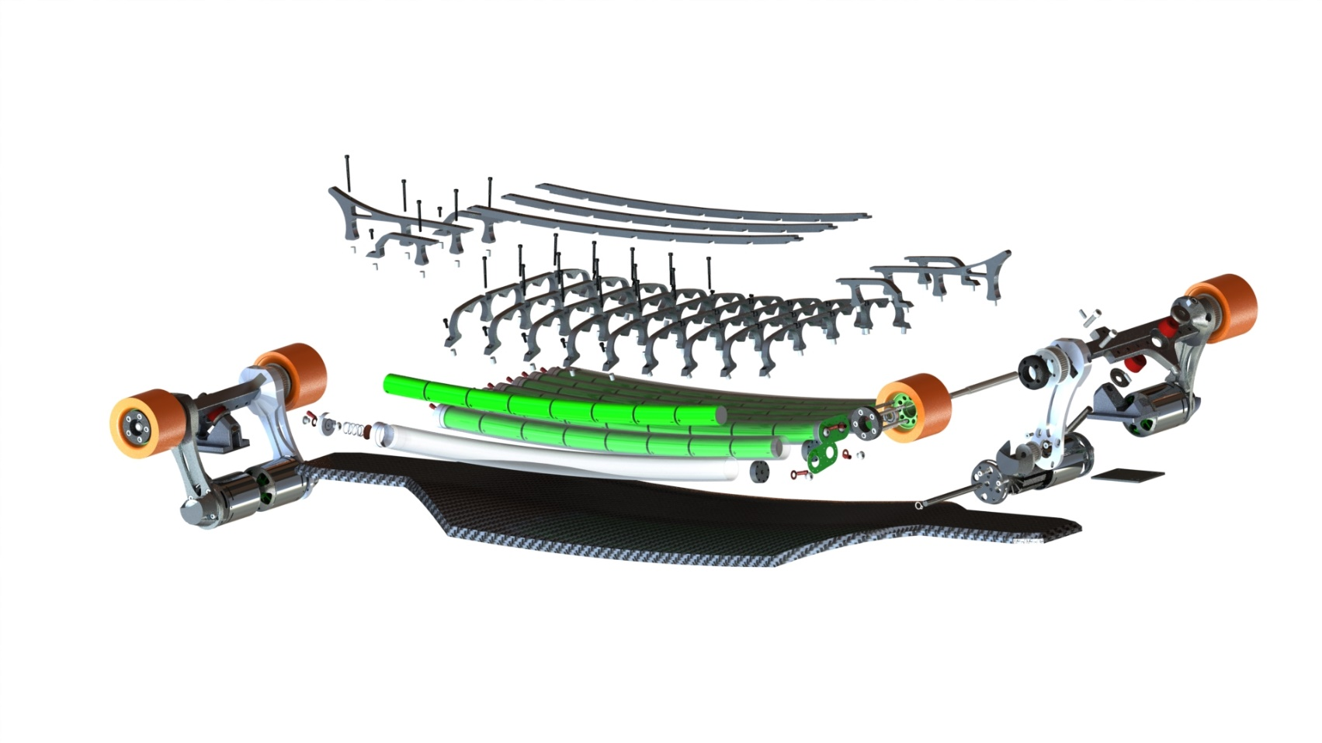A close up of a device

Description generated with very high confidenceAfter a year break in the building process I set out to reimagine the mechanical superstructure.

A close up of a device

Description generated with high confidence

Completed

2014-2015

|  |  |
| --- | --- |
| A picture containing indoor, floor, wall, table  Description generated with very high confidence A sign on the floor  Description generated with high confidence | A picture containing floor, bicycle, indoor  Description generated with very high confidence |
| V4 Carbon Fiber Deck | V2 10W RGBW Headlights, Backlights |
| 3 failed designs | 4 x ILD6150 LED Drivers  Atmel 328 Micro  12-65 operating voltage |

|  |  |
| --- | --- |
| A circuit board  Description generated with high confidence |  |
| Daisy chainable single cell BMS | Custom Truck and Motor Assembly |
| Attiny 85 Micro  Isolated I2C channel  Onboard boost converter | 2 x Turnigy 7464 BLDC Motors  2 x Kegel Orangatang 80mm Wheels  CNCed and turned at Redwood City Techshop. |

In the Pipeline:

2017-

|  |  |
| --- | --- |
| A picture containing indoor, wall, floor  Description generated with very high confidence | A picture containing indoor, window, table, building  Description generated with high confidence |
| Battery Pack | Carbon fiber deck |
| Needs high current contacts in between the batteries as well as the wiring from the individual cells to the BMS | Molds CNCed  Carbon fiber bought |
|  |  |
| A picture containing sky, electronics  Description generated with high confidence | A picture containing table, indoor  Description generated with very high confidence |
| Sensor Module | 1.5kW charger |
| Raspberry Pi central module  GPS  Altimeter  Design and development in collaboration with Sam Ragsdale | Tested at 900W withought water-cooling  Compatible with 240V for 3kW+ charging  Design and development in collaboration with Anton Zaytsev |

In the Near Future

Headlight, Backlight enclosure

Integrated battery management system

Waterproofing cover

Remote-control system

Components not designed or manufacture by project team:

VESC – BLDC motor speed controller

Turnigy 6374 BLDC motors

Nyko Wii nunchuck – repurposed for the control of the ESCs

Kegel Orangatang 80mm Wheels

